**React Application Deployment – Submission**

**GitHub Link**

* <https://github.com/keerthana-v184/Brain-Tasks-App.git>

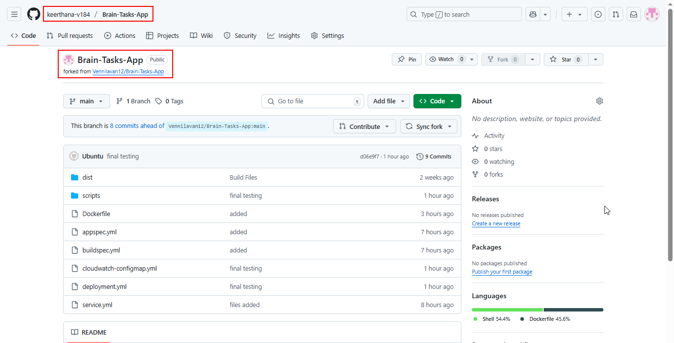

**Document Link of project**

* <https://docs.google.com/document/d/1yHj9ilwvNYl8I4cPdNtO3Qpzkp6DF_5q/edit?usp=drive_link&ouid=115259677499761429277&rtpof=true&sd=true>

**Application deployed Kubernetes Load balancer ARN:**

* <http://a9047f4094c2544a4907015c5ece60fb-1338554286.us-east-1.elb.amazonaws.com:3000/>

